Name: Karl Pedroche

Date 4/16/20

CIS 200 Project 3

# Problem Statement

Create a program that play Solitaire

# ReadMe *(Optional)*

4/23/20 This project was a bust. The only thing that works is the display, the actual deck of cards, and putting cards into the sorted pile, as well as sorting the deck of cards in forward and backward order. Everything else just about doesn’t work. I feel like I’m so close to getting the thing to actually swap but I don’t have the time to do that along with the other requirements like adding an outfile creator and instructions (“Press any key to crash the program”). Though I can’t really do any these things until AFTER I had everything working, which isn’t possible now

4/24/20 Got the moving of cards to work properly. Adjusted the shuffle method to be more random. Also got around to making it print an outfile and created instructions

Instructions: Give number between 1-3 depending on what you want to do.

If you press 1, enter the card you want to send (Example “AH”). Has to be all caps.

If you press 2, enter the card you want to send (Example “AH”). Then the number of the column you want to put it in

If you press 3, no other inputs are needed

# Test Plan

|  |  |  |  |  |  |  |
| --- | --- | --- | --- | --- | --- | --- |
| Test # | Valid / Invalid Data | Description of test | Input Value | Expected Output | Actual Output | Test Pass / Fail |
| 1 | valid | Check if color is returned | “10D” | b | b | Pass |
| 2 | valid | Check if suite is returned | “10D” | D | D | pass |
| 3 | valid | Check if number is returned | “10D” | 10 | 10 | Pass |
| 4 | valid | Check if deck loads cards into a queue properly | deck.enqueue(Card(“AH”) | Card is loaded into queue | “Attempting to reference a deleted function” | Fail |
| 5 | valid | Check if deck shuffles propperly | deck.shuffle() | Loaded cards are shuffled | nulPointer Exception | fail |
| 6 | Valid | Check if ascending sort works | deck.sortAscend | Loaded cards are sorted | nulPointer Exception, some strange thing where I’m gaining/losing cards | fail |
| 7 | valid | Check to see descending sort works | deck.sort descend | loaded cards are sorted the opposite way | loaded cards are sorted the opposite way | pass |
| 8 | valid | Check to see if decks properly unloads cards into game columns | colOne.push(deck.getTopCard()) | A card is dequeued from deck and pushed into colOne’s stack | A card is dequeued from deck and pushed into colOne’s stack | pass |
| 9 | valid | If card is “face down” trying to get it’s type will show a “?” | card.getType() | “?” | “?” | pass |
| 10 | valid | if sent a command, the topmost card in a stack will go face up | colOne.reveal() | faceUp = true | faceUp = false | fail |
| 11 | valid | When asked to print all rows, they print as expected | colOne-colseven.desplayRow(0-13) | displays all rows in an upper triangle, with only the bottommost cards revealed | displays all rows in an upper triangle, with only the bottommost cards revealed | pass |
| 12 | valid | 3 cards are given to the hand and the last card given is displayed | hand.enqueue(Card(),temp.getType()) | [ AC, 1C,2C] | [2C] | pass |
| 13 | valid | sorted decks are displayed properly | sortedAce.getSize() | 0 | nulPointer Exception | fail |
| 14 | invalid | having no correct cards in discard pile when trying to put something into sorted pile will throw an exception | handToSorted() | “Invalid Move” | “Invalid Move” | pass |
| 15 | valid | having the correct cards in the discard pile when trying to put something into sorted pile will let you place it there | handToSorted() | “The “X” in the discard pile went to the sorted Heart Pile” | “The “X” in the discard pile went to the sorted Heart Pile” | pass |
| 16 | valid | When the deck runs out of cards from flipping, the discarded cards go back to the deck | discard() x11 times | deck gets restocked | deck gets restocked | pass |
| 17 | valid | If player empties deck 3 times, game over | discard x33 times | game over | game over | pass |
| 18 | valid | when given a card type, the program scans the playboard for it, returning its position | KH | Row 2, 1 deep | Row 2, 1 deep | pass |
| 18 | valid | moving multiple cards to a column | 7 , 8 , 9 | 7, 8 , 9 , 10 | 8, 9 , 10 | fail |

# Screenshots

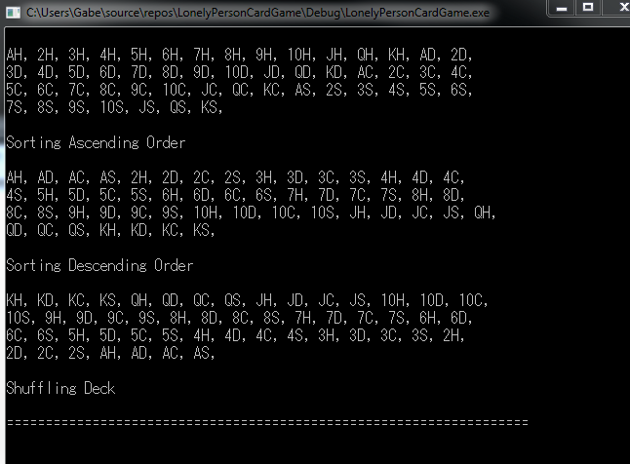

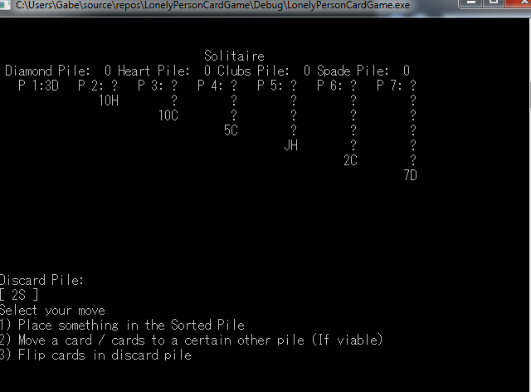

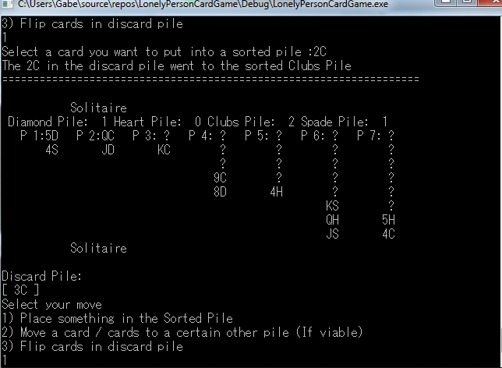

Some weird bug where random stuff is printed on the game board

